补：第五章

●P203

#include<iostream>

using namespace std;

int p=0;

struct Point{

int x;int y;};

int Line(Point ary[],int n);

int main()

{

int n;

cout<<"请输入点的个数："<<endl;

cin>>n;

Point \*aa=new Point[n];

for(int i=0;i<n;i++)

cin>>(\*(aa+i)).x>>(\*(aa+1)).y;

for(int i=0;i<n;i++)

cout<<"("<<(\*(aa+i)).x<<","<<(\*(aa+1)).y<<")";

Line(aa,n);}

Line(Point ary[],int n)

{int j=0;

for(j;j<n-1;j++)

if((\*(ary+j)).x!=(\*(ary+j+1)).x) break;

if(j==n-1) cout<<"这些点在垂直线上"<<endl;

else p++;

for(j=0;j<n-1;j++)

if((\*(ary+j)).y!=(\*(ary+j+1)).y) break;

if(j==n-1) {cout<<"这些点在一条水平线上"<<endl;}

else p++;

switch(p)

{

case 2: cout<<"这些点既不在垂直线上也不在一条水平线上";

default: cout<<"over";}

delete[]aa;

}

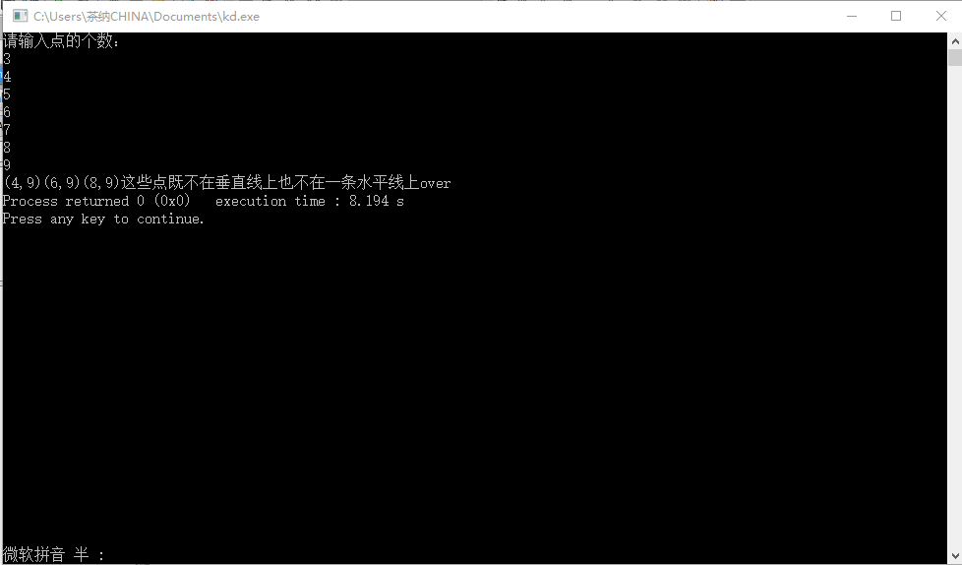

●P234第2题

#include<iostream>

using namespace std;

struct pr

{

char name[20];

unsigned int id;

double score;

};

class student

{public:

char name[20];

unsigned int id;

double score;

void input(){

cout<<"name?";

cin>>name;

cout<<"id?";

cin>>id;

cout<<"score?";

cin>>score;}

void output()

{

cout<<"name:"<<name<<"\tid:"<<id<<"\t\tscore:"<<score<<endl;

}

};

int main()

{

student s;

s.input();

s.output();

}

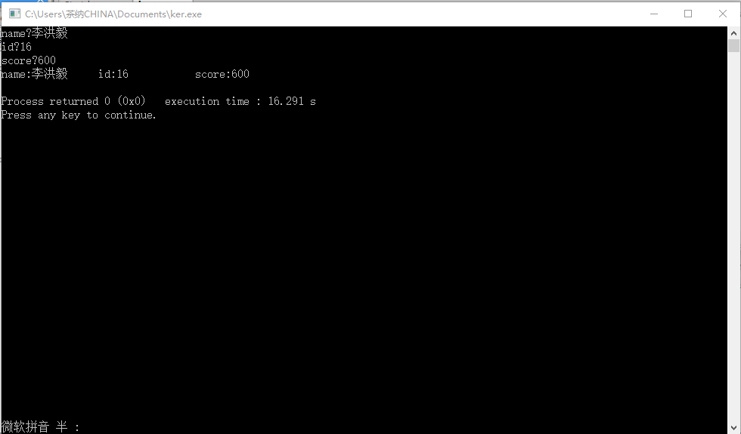

●P242第1题

#include<iostream>

using namespace std;

int number=10;

class Book

{public:

Book(char\*,int ,int );

void display()

{cout<<"bookname:"<<bookname<<"\tprice:"<<price<<"\tnumber:"<<number<<endl;}

void borrow()

{if(number){number--;

cout<<"当前图书数量："<<number<<endl;}

else cout<<"此书已经没有存数："<<endl;}

void restore()

{

number++;

cout<<"当前图书数量："<<number<<endl;

}

char \*bookname;

int price;

int number;

};

Book::Book(char\*p,int x,int y)

{bookname=new char[20];

bookname=p;

price=x;

number=y;

}

int main()

{

int i=0;

char sp[]={"宽客人生"};

char\*s=sp;

Book k(s,20,10);

while(1)

{

cout<<"显示图书情况--1，借阅书本请按--2，归还书本请按--3"<<endl;

cin>>i;

switch(i)

{

case 1:k.display(); break;

case 2:k.borrow();break;

case 3:k.restore();break;

}

}

}

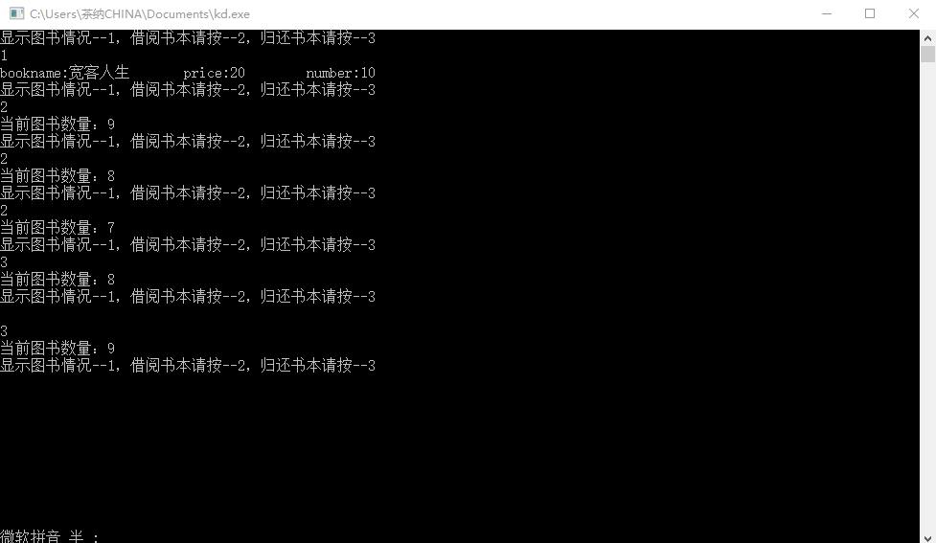

●P242第3题

#include<iostream>

using namespace std;

class student

{static double total;

static double count;

public:

double score;

void scoretotalcount(double s)

{

cout<<"请分别输入学生成绩(结束时输入over）："<<endl;

for(;;){

cin>>score;

if(!score) break;

count++;

total+=score;

}}

static void sum(student \*pr)

{

cout<<"返回总分："<<pr->total<<endl;

}

static void average(student\*pr)

{

double av;

av=(pr->total)/(pr->count);

cout<<"平均分："<<av;

}};

double student::total=0;

double student::count=0;

int main()

{

student stu;

stu.scoretotalcount( 2) ;

stu.sum(&stu);

stu.average(&stu);}

